**NAME:VISHWAS M**

**SRN: PES2UG20CS390**

**SEC: F**

**SUB : OPERATING SYSTEM LABORATORY**

**WEEK: 2**

**Linux commands and**

**Fork():**

**SCREENSHOTS OF THE COMMANDS EXECUTED:**

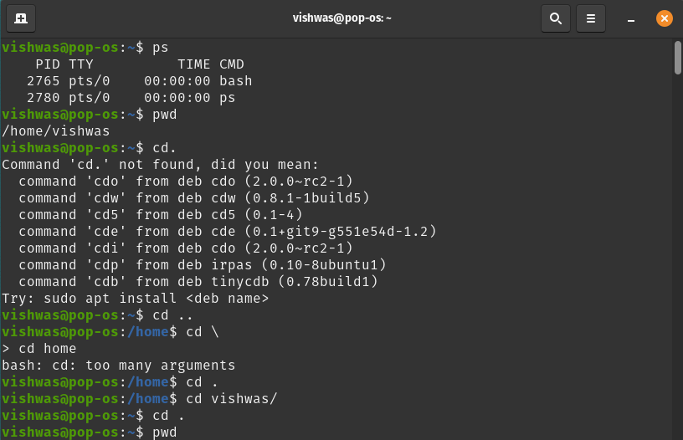

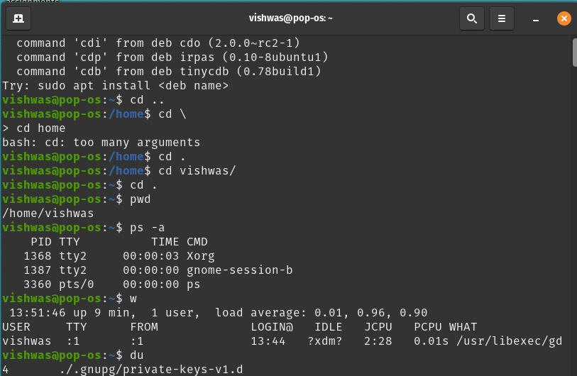

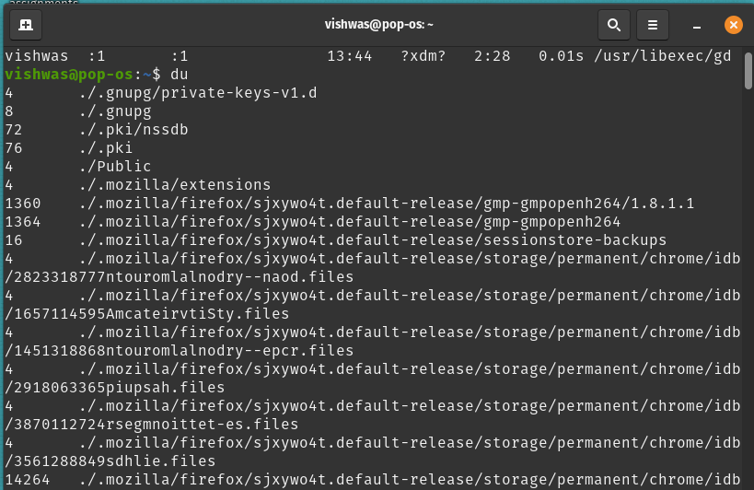

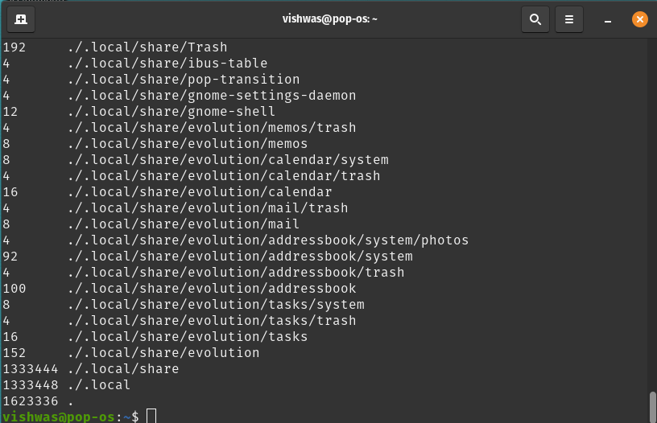

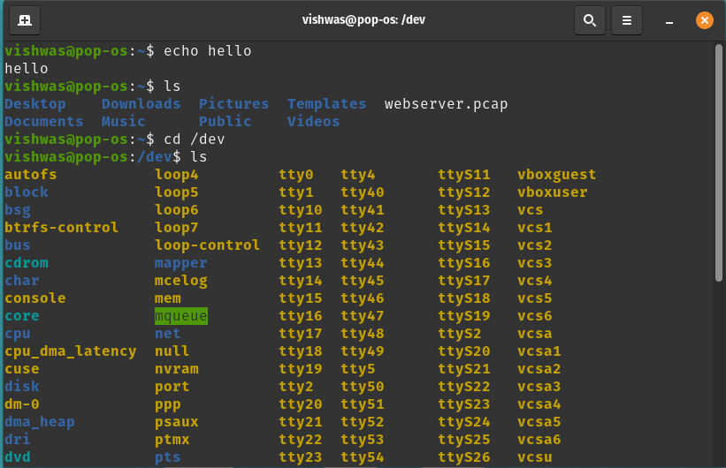

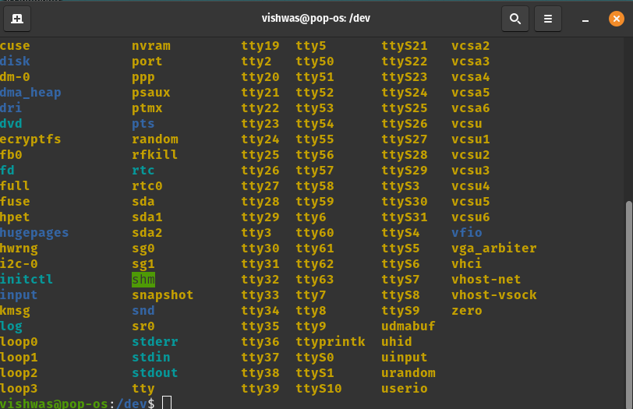

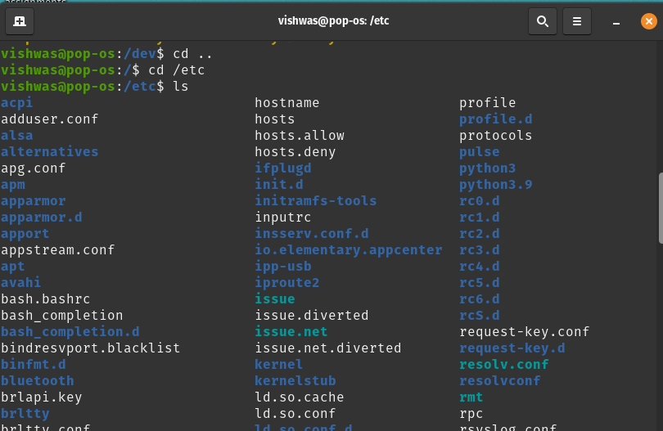

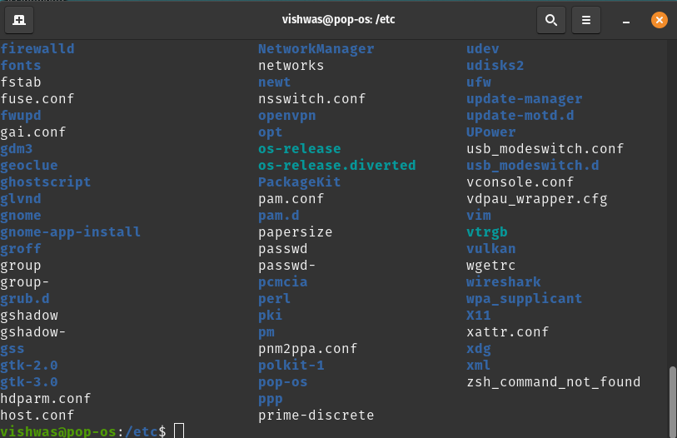

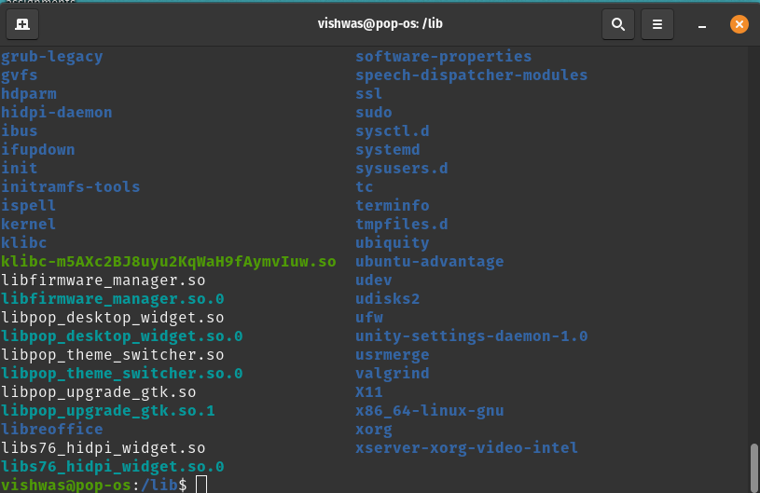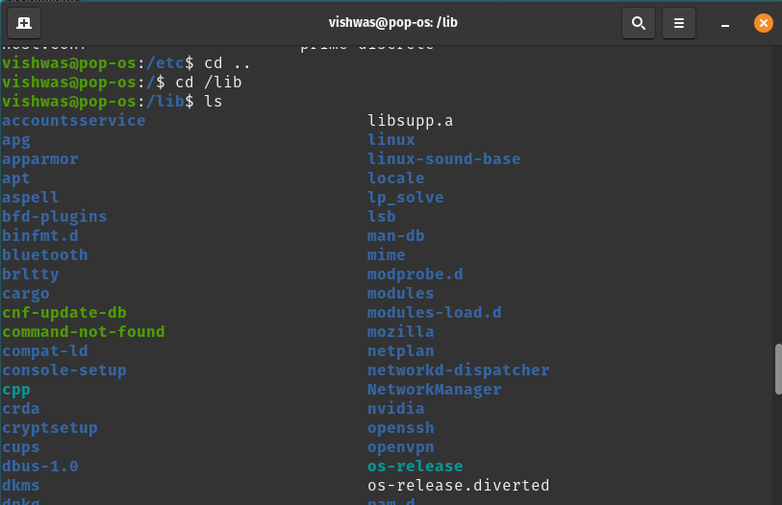

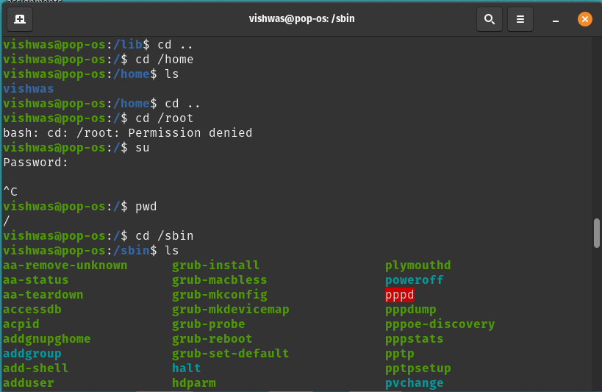

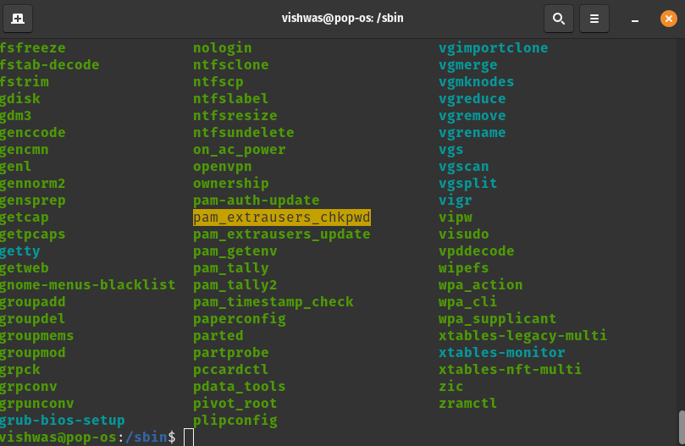

Fork():

The output of the program is executed in the order of . Here ‘n’ is the number of times the fork() command is used inside the main function. There are more commands just like fork() such as exit(), terminate(), wait(), getpid() , read(), write() and many more. These commands are used to alter the process state in the operation system.

The output of the program when fork() is used one time will be two times.

The output of the program when fork()

Is used two time will be four times.

The output of the program when fork()

Is used three times will be eight times.

**when fork() used 2 time:**

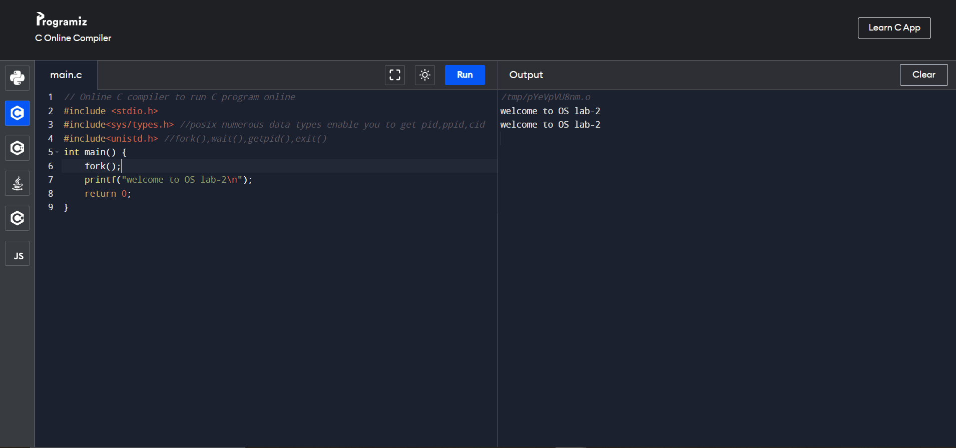

**when fork() is used 2 times:**

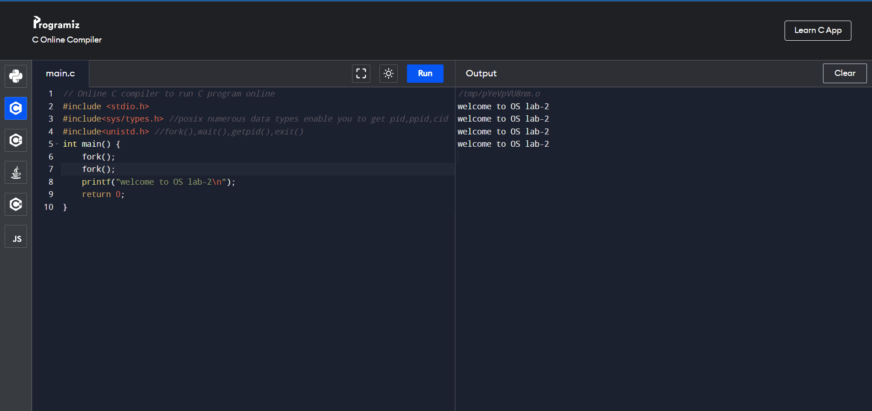

**when fork() is used 3 times:**

